Glacier Birding Adventures & Birding Experiences Costa Rica
present

Costa Rica: Northern Highlights
February 22 - March 5, 2023
This tour is an exciting and easy-going trip to the top destinations of northern Costa Rica.

From the high-elevation cloud-forest to the lush lowland rainforest, we will enjoy the immense biodiversity of the 'caribbean slope' of the country. Staying at great lodges set in the forest gives us the opportunity to experience the wildlife of Costa Rica right outside our rooms! That, plus 2 boat tours where expert local guides will help us spot specialty birds in the most bird-rich wetlands of the country!

Price: $4,095 per person
due 90 days before tour start date.
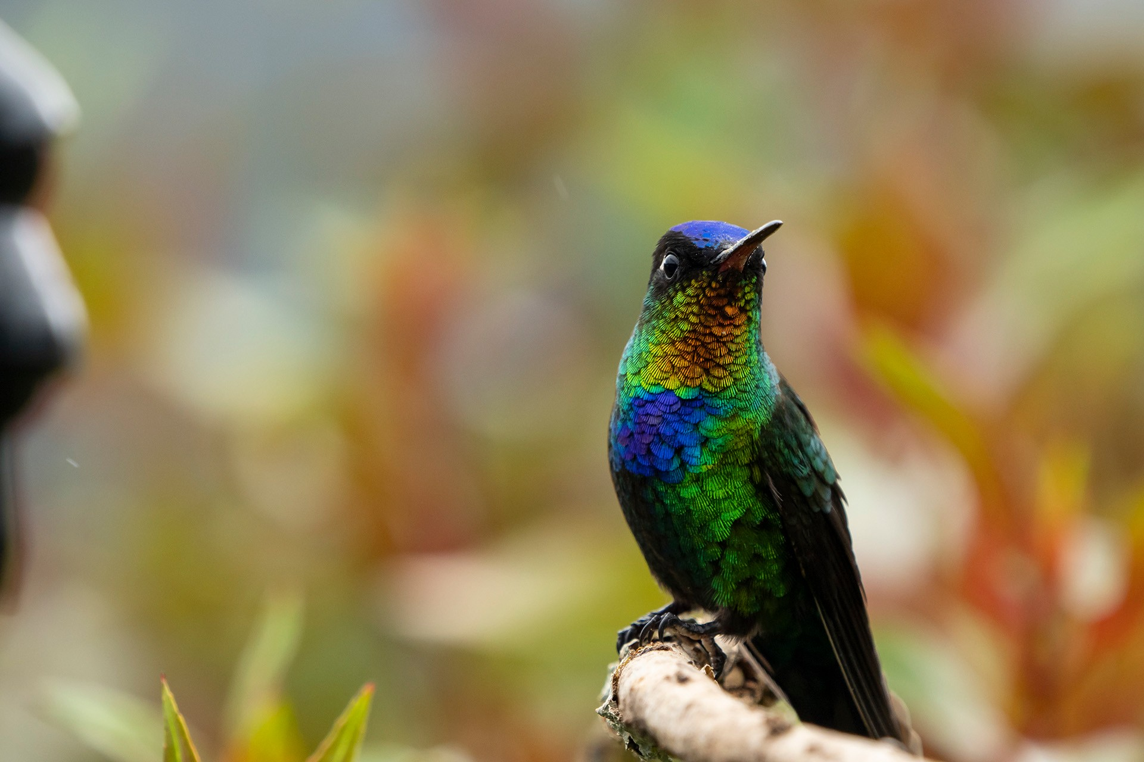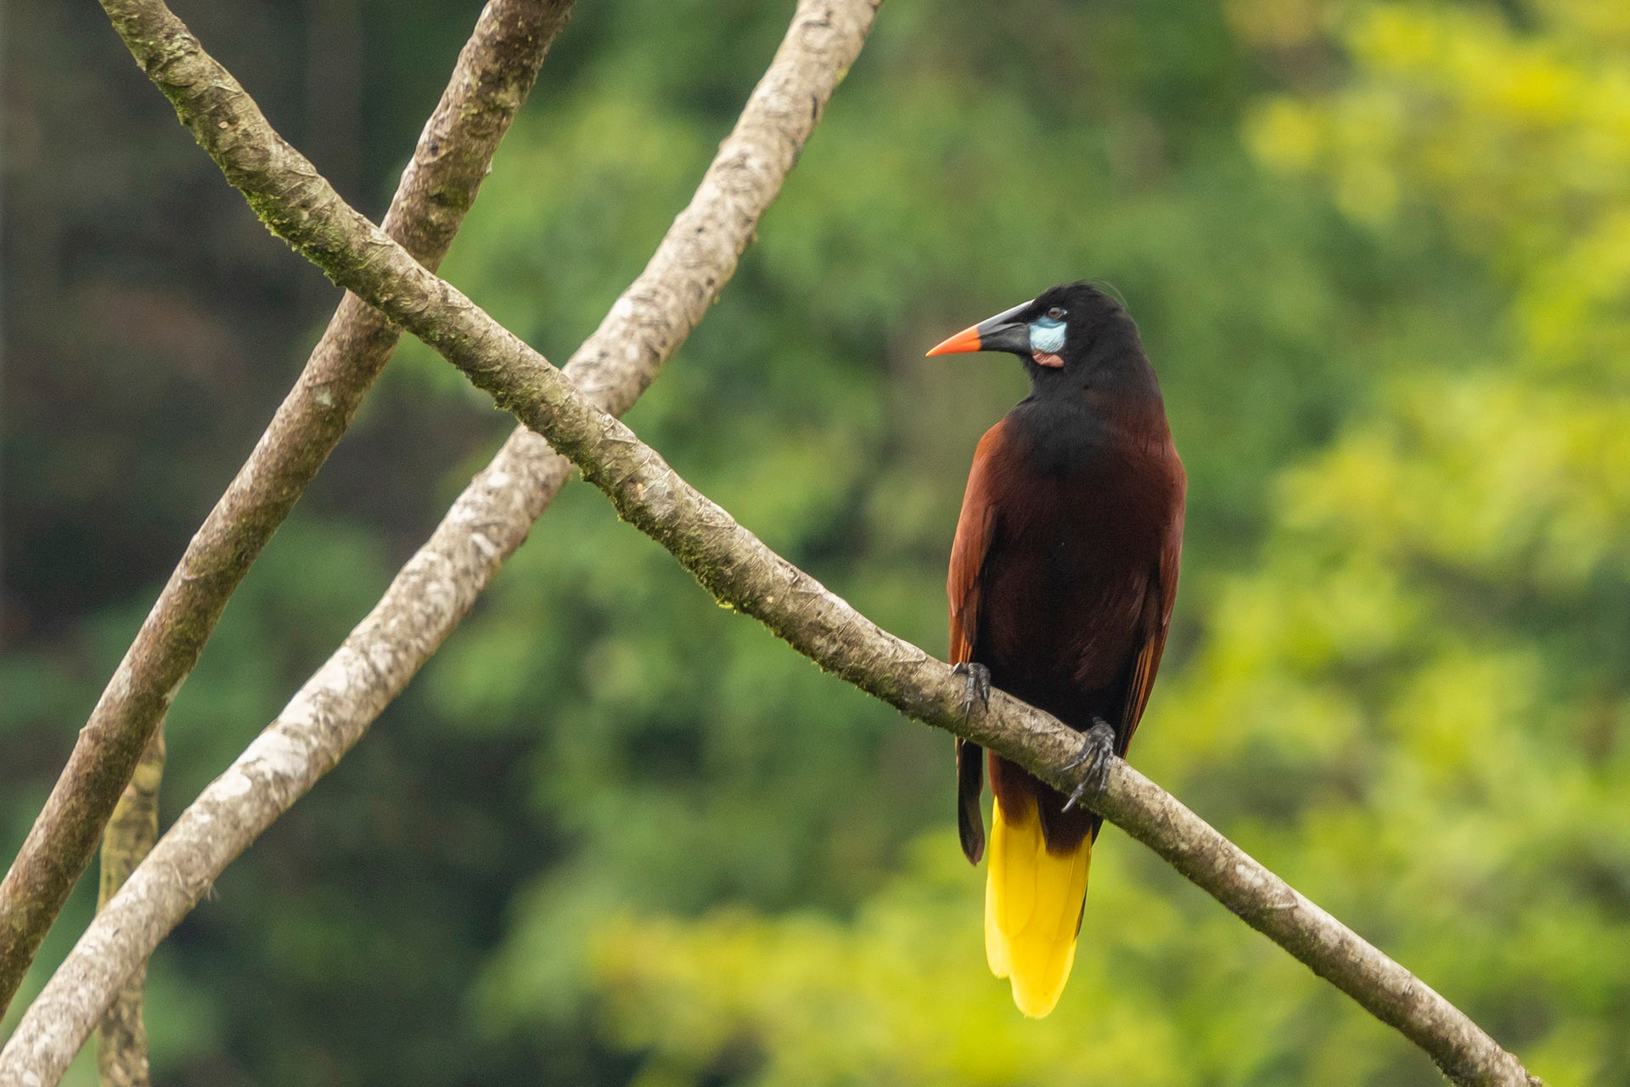$500 deposit is required to secure your spot.
From: San José, Costa Rica Tour limit: 8 participants Activity Level: Light/Moderate

Fiery-throated Hummingbird, one of the highland hummingbird species we will see in San Gerardo de Dota.
Montezuma Oropendulas, huge Icterids related to orioles, build large hanging nests in colonies, something we will see in the Caribbean lowlands.

Itinerary Overview

Feb 22: Airport pick-up and orientation dinner at hotel near Alajuela.

Feb 23: Morning birding and move to El Copal, our lodge for 2 nights.

Feb 24: Birding El Copal

Feb 25: Move to San Gerardo de Dota in the Talamanca mountains.

Feb 26: Birding the "highlands"

Feb 27: Birding in the 'paramo' and afternoon drive to La Selva Biological Station
Feb 28: Birding around La Selva

Mar 1: Move to Cano Negro, afternoon boat trip at Medio Queso wetlands.

Mar 2: Morning boat trip at Cano Negro, afternoon drive to Arenal.

Mar 3: Birding Arenal area.

Mar 4: Drive to San Ramon for Three-wattled Bellbirds, end at hotel near Alajuela and airport. Evening dinner and final checklist count.

Mar 5: International departures.

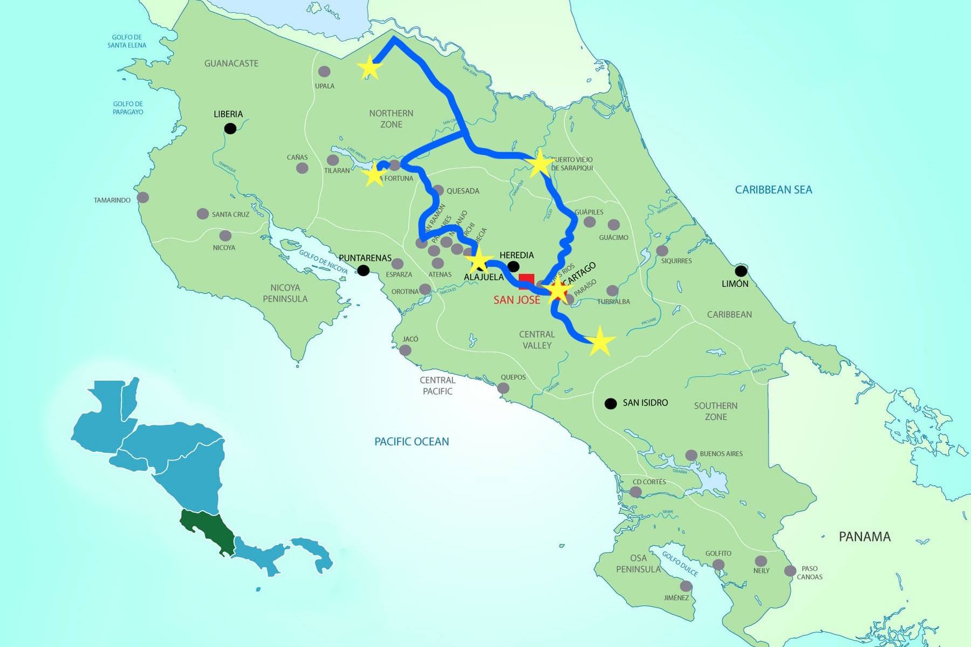
Cano Negro
La Selva
Arenal
El Copal

San Gerardo de Dota

Detailed Itinerary
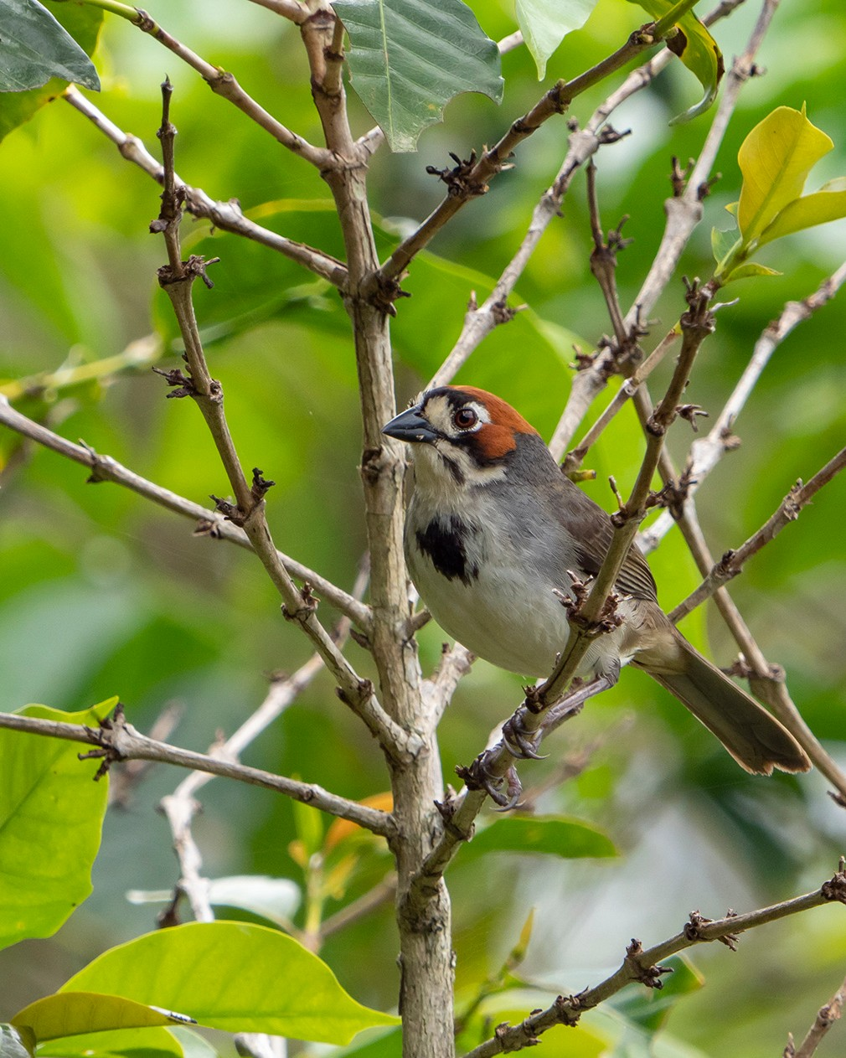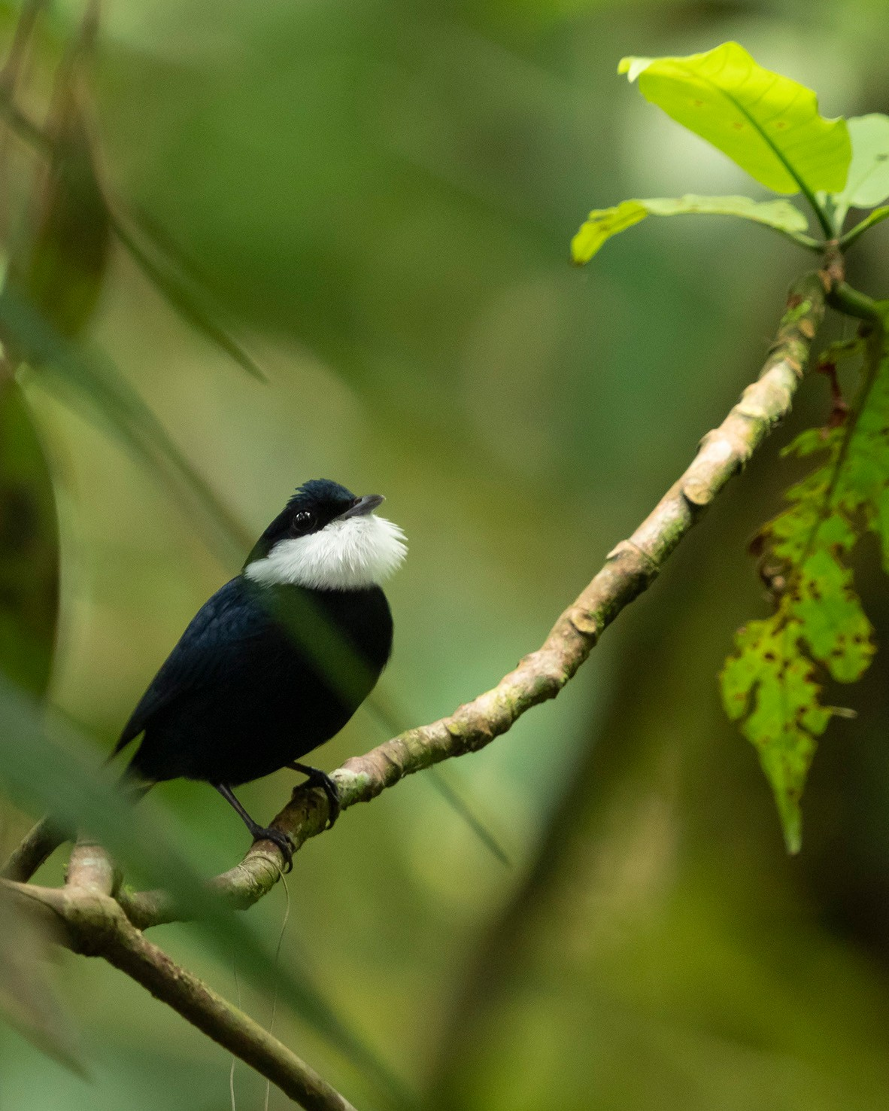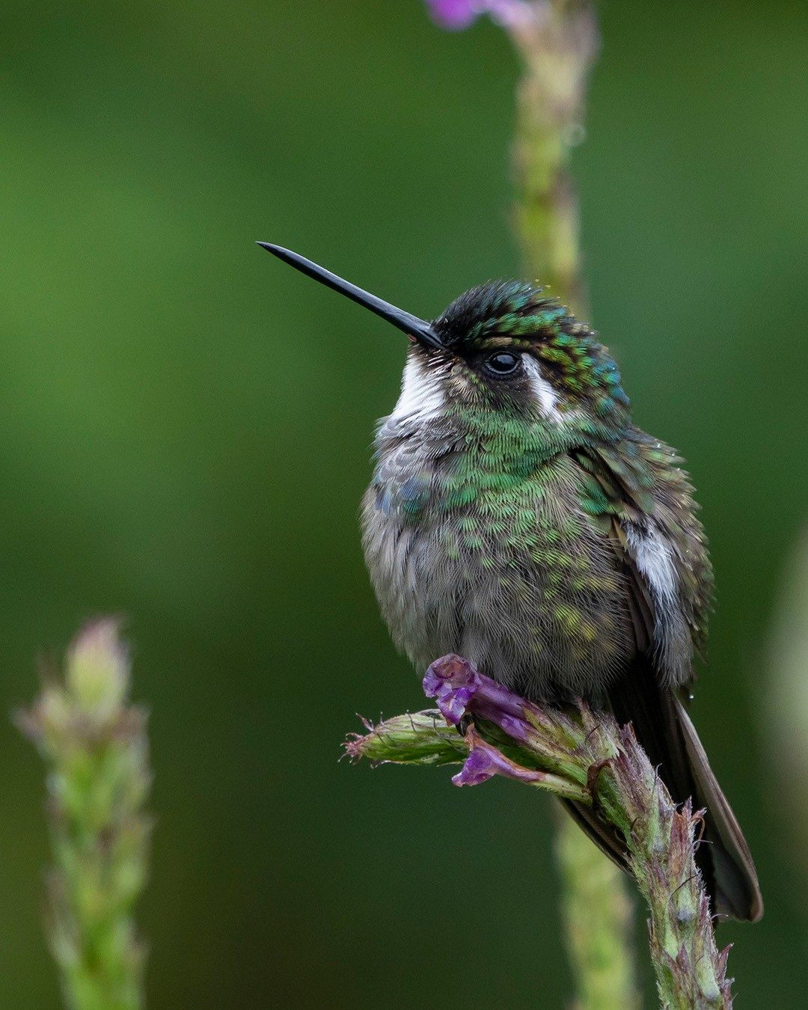Feb 22nd -Day 1: Arrival and Orientation
Airport pick-up and transfer from Juan Santamaría International (SJO) to our hotel for dinner and orientation.
Recommended to have flights arrive no later than 3:00 PM in order to have all participants for the dinner and orientation.
Feb 23rd -Day 2: Cabanis's Ground-Sparrow & El Copal
After breakfast, we will move across the Central Valley towards our destination for the next 2 nights, the wonderful birding lodge and local reserve, El Copal! Along the way there, we will stop for a few Central Valley specialties, focusing on the valley endemic Cabanis's Ground-Sparrow. A delightfully chunky sparrow that has made a home in the small coffee plantations all throughout the valley.
After arriving to El Copal, we will do some leisurely birding of the grounds, which are quite active with hummingbirds! Coffee and hummingbirds, always a good combo!
Feb 24th -Day 3: El Copal
We will spend the day exploring the grounds of El Copal, marveling at the biodiversity found around the lodge. This “caribbean foothills” site gets a great mix of species, and we will get our first introductions into so quintessential neotropical bird families like Toucans, Trogons, Motmots, and Antbirds. Several specialty species can be found in the area, including Snowcap, Ashy-throated Chlorospingus, and Tawny-chested Flycatcher.
Other likely birds include: Crested Guan, White-collared Swift, Green Hermit, Collared Trogon, Smoky-brown Woodpecker, Brown-hooded Parrot, Dull-mantled Antbird, Spotted Woodcreeper, White-ruffed Manakin, Scale-crested Pygmy-Tyrant, Black-headed Nightingale-Thrush, Tawny-capped Euphonia, Bay-headed and Emerald Tanagers, and Scarlet-thighed Dacnis.
Our first day surrounded by nature in the rich rainforests of Costa Rica will a good one, and not just for the birds. There are so many other creatures and plants to see and enjoy. We will learn a bit about tropical ecology, plant and animal life, and have time to just soak it all in. The major benefit of staying at a birding lodge is that we won't have to leave to do any of our birding, and participants can come and go, rest and explore, on their own.
Feb 25th - Day 4: El Copal to the Talamanca Highlands
After breakfast, we will head upslope to the high altitudes of the Talamanca mountains where we will stay for 2 nights! Along the way, we will stop for locally grown and brewed coffee and beer at the famous Casa Dowii (named for the Spangle-cheeked Tanager - Tangara dowii) which also holds the chance to see Buff- fronted Quail-Dove and Buffy-crowned Wood-Partridge coming into the feeders, among other species.
We will spend the afternoon enjoying an amazing show at active hummingbird feeders and looking for some of the Talamanca’s most showy endemics. Some of the main hummingbirds include Talamanca and Volcano Hummingbirds, Lesser Violetear, White-throated Mountain-Gem, and the jaw-dropping Fiery-throated Hummingbird, my personal favorite hummingbird in Costa Rica!

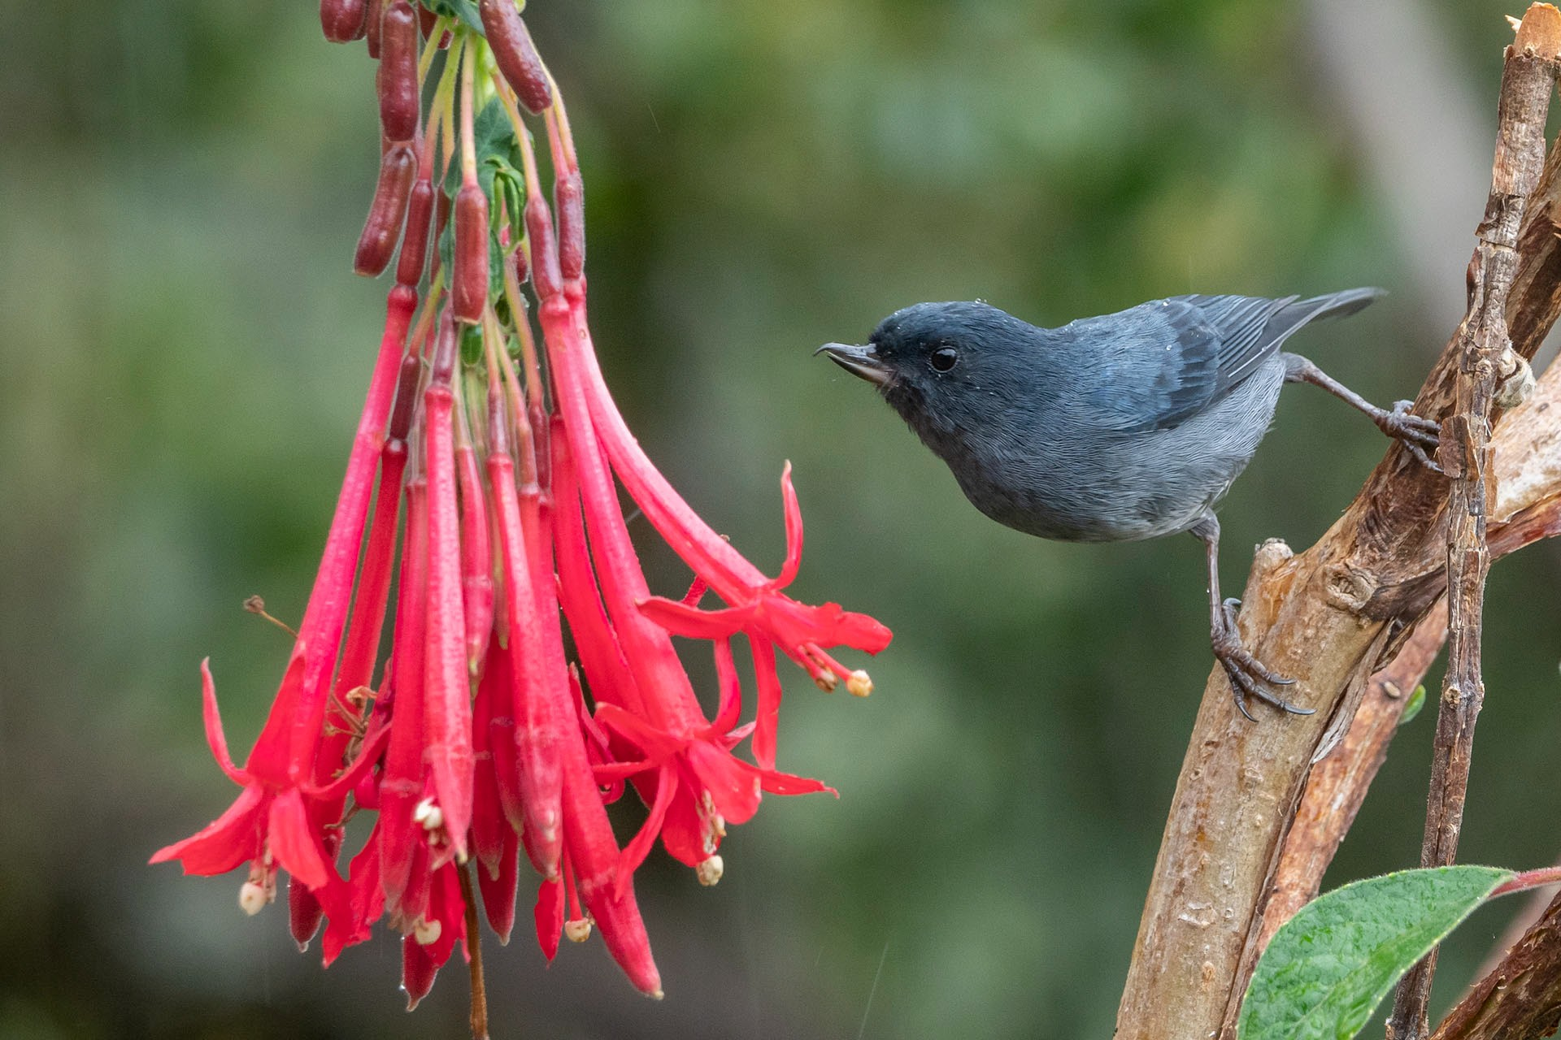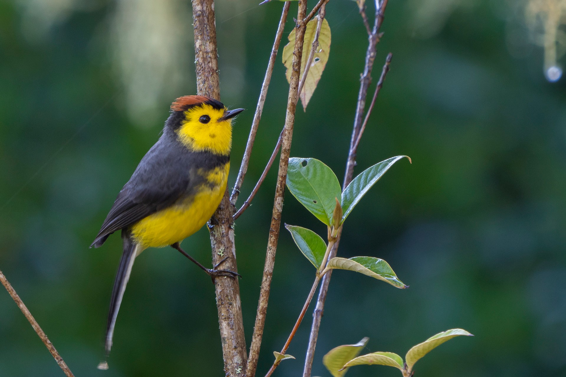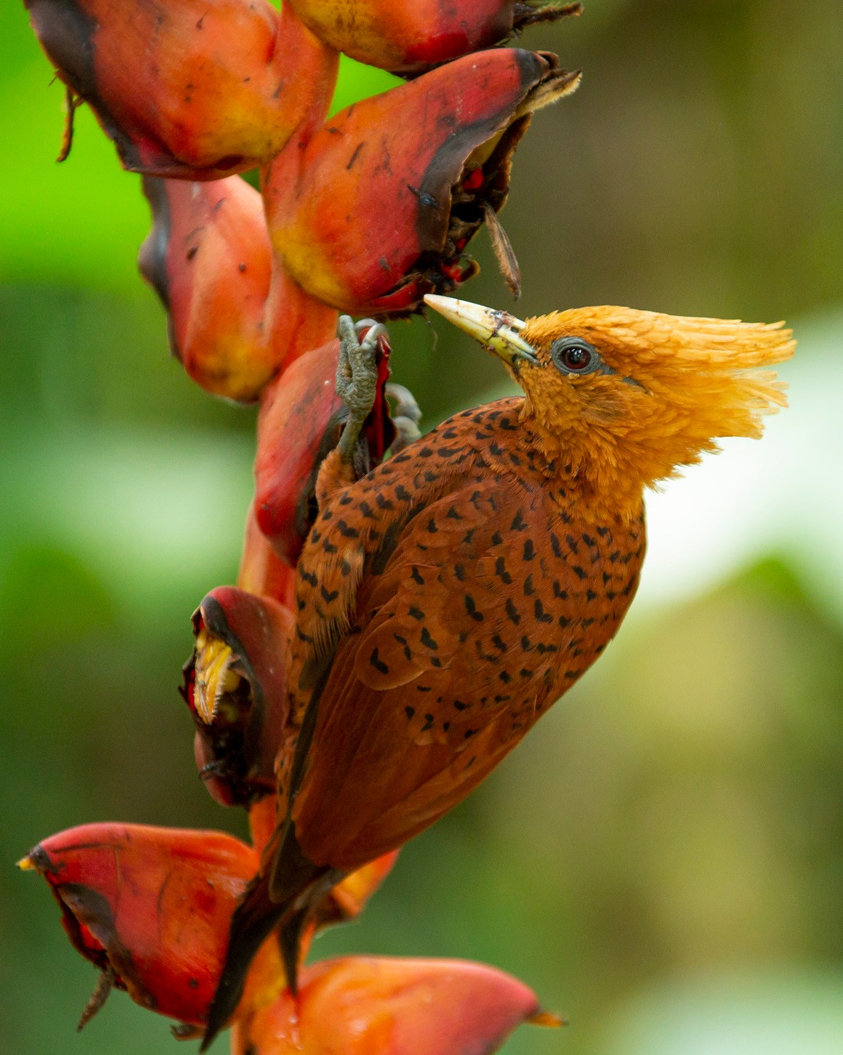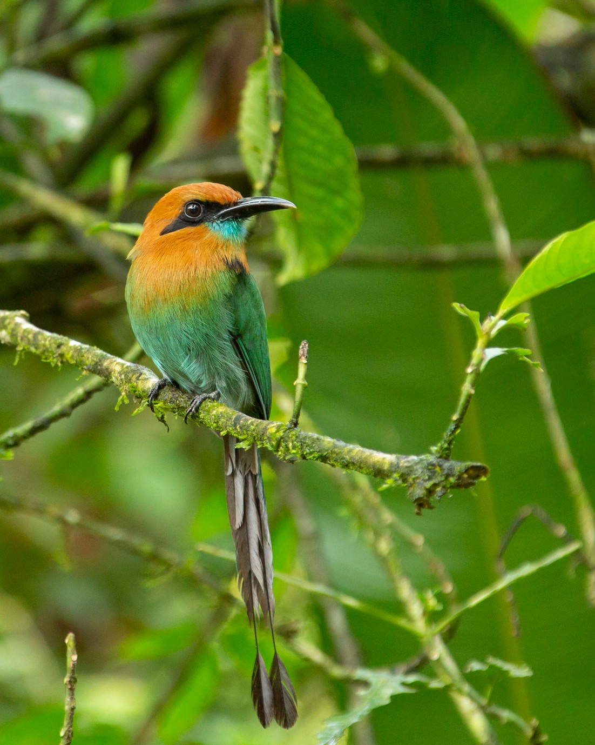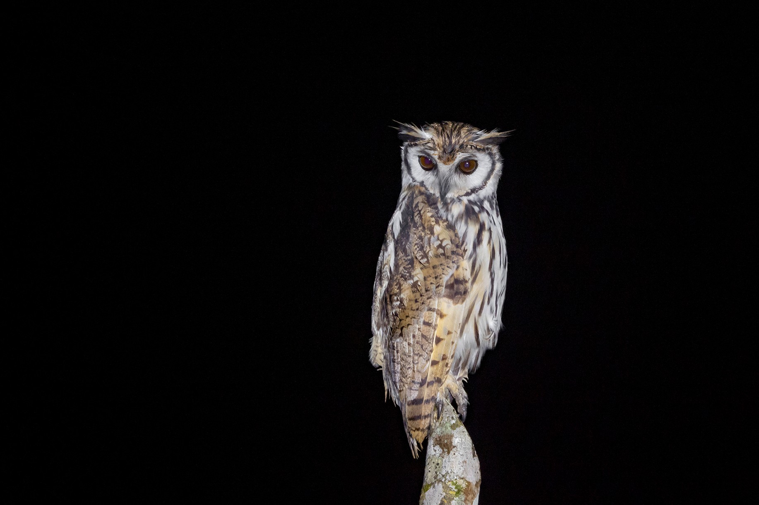Feb 26th - Day 5: Resplendent Quetzal & Talamanca endemics
The Talamanca highlands hold nearly 60 endemic species, shared between Costa Rica and western Panama. On our full day in the mountains, we will focus on finding as many as we can while enjoying the crisp mountain air and gorgeous vistas. Some targets include: Slaty Flowerpiercer, Long-tailed Silky-Flycatcher, Yellow-thighed Brushfinch, Collared Redstart, Flame-throated Warbler, Large-footed Finch, Streak- breasted Treehunter, Golden-browed Chlorophonia, and Black-capped Flycatcher. One of the classic targets up here is the Resplendent Quetzal, and while it itself isn’t a Talamanca endemic, it is one the world’s top birds and these mountains are one of the best places to see one!
We will most likely eat lunch at Miriam’s, a famous eatery that has active bird feeders on the back patio. The local trout comes highly recommended!
While in the highlands, we will also go owling for a shot at Bare-shanked Screech- Owl and Dusky Nightjar.
The highlands are a really special place, and anyone who enjoys an excellent cup of coffee on a chilly morning in the mountains will enjoy spending a couple days up there.
Feb 27th - Day 6: Timberline birds & a drive to the Caribbean lowlands
We will start our morning of birding above treeline and above 10,000 feet! Up above the clouds lives 2 species only found here, Volcano Junco and Timberline Wren. We will brave the chilly temps in search of these birds, and then make our way down to a whole other world; the Caribbean Lowlands. Hot and steamy primary rainforest will be quite different from the cold páramo at the top of the country. After making another stop or two, we finally arrive at the La Selva Biological Station.
Feb 28th - Day 7: La Selva Biological Station
Staying for 2 nights at La Selva affords us the opportunity to soak in the glorious biodiversity of this world-famous birding site! With literally hundreds of species possible, this is the most biodiverse spot of the trip. And it’s not just birds! All kinds of amphibians, butterflies and other insects, and cool plants are waiting to be appreciated just a few steps from of our cabins! Along with the birds, we will try to find some unique fauna in the area like the fun Strawberry Poison Dart frogs that are common in the Caribbean lowlands.
A few target species for our time in La Selva include: Great Tinamou, Scaled Pigeon, Great Green Macaw, Laughing Falcon, Lesser Swallow-tailed Swift, White-necked Jacobin, Long-billed Hermit, Gray-headed Kite, Semiplumbeous Hawk, Middle American Screech-Owl, Chestnut-colored Woodpecker, Fasciated Antshrike, Chestnut-backed Antbird, Plain-brown Woodcreeper, White-collared Manakin, Snowy Cotinga, Royal Flycatcher, Black-capped Pygmy-tyrant, Black-throated Wren, Chestnut-headed Oropendula, Dusky-faced Tanager, Broad-billed Motmot, and Green Honeycreeper. Accommodations at La Selva lean towards rustic, but staying well within the rainforest is an experience well worth it. Well-made cabins are clean and comfortable, albeit without air conditioning. Falling asleep to owls and nightjars and waking up to Howler Monkeys is an experience hard to forget!
Mar 1st - Day 8: Morning at La Selva & the Medio Queso wetlands
After a wonderful morning birding around La Selva, we will head north towards Caño Negro, with a stop at the Medio Queso wetlands just south of the Nicaraguan border. Here we will take our first of two boat trips!
With a local expert guide, we will look for Pinnated Bittern, Lesser Yellow-headed Vulture, and a few other birds harder to find any further south.
After dinner we will search for night birds just outside of the tiny town of Caño Negro, with Great Potoo, Striped Owl, Black-and-White Owl, and Pacific Screech- owl as our targets.

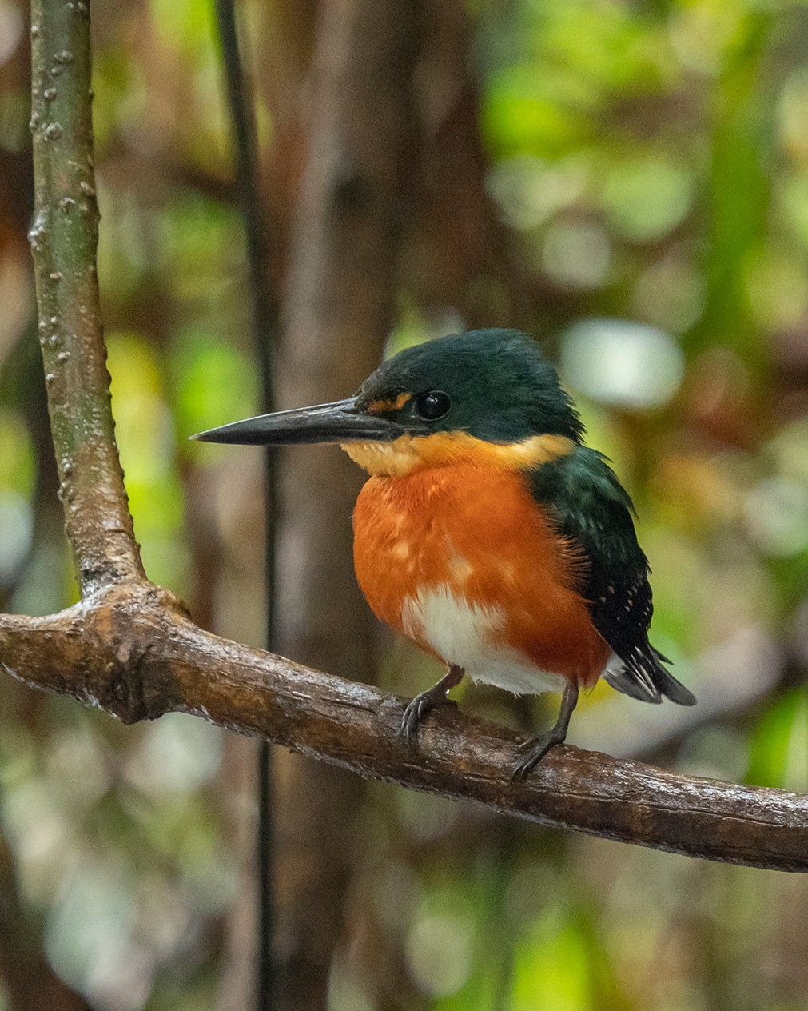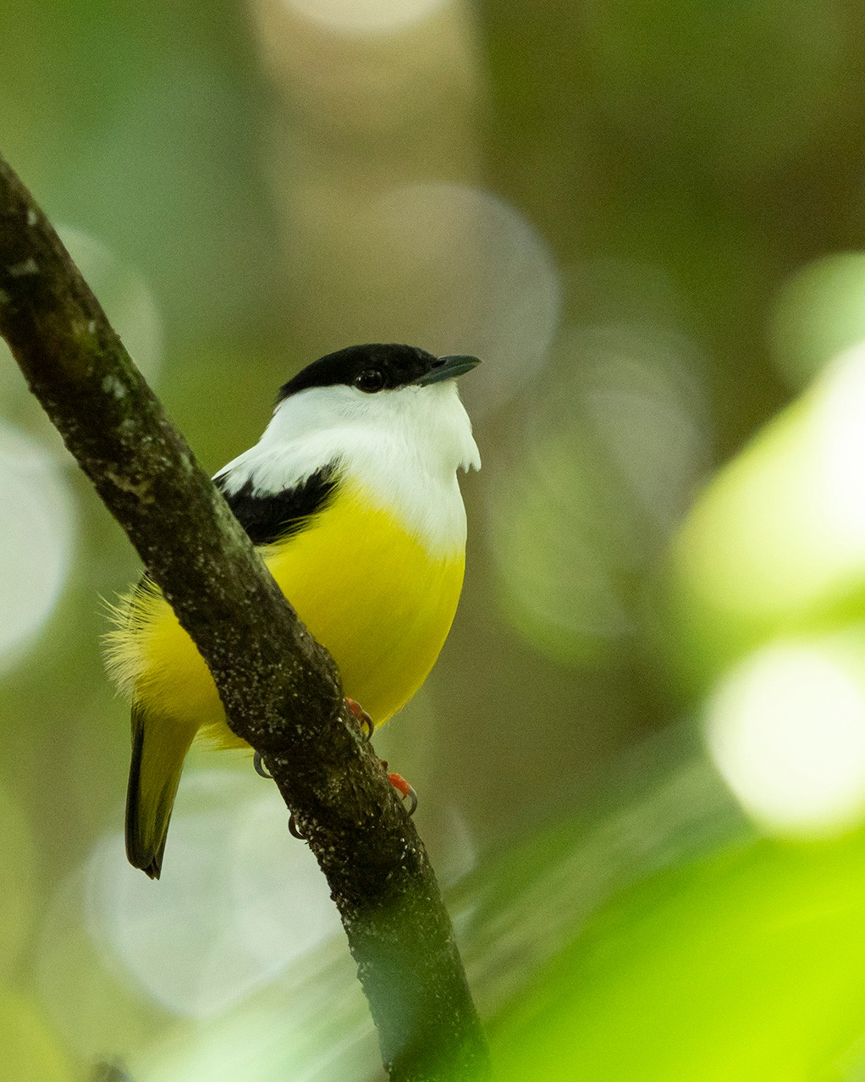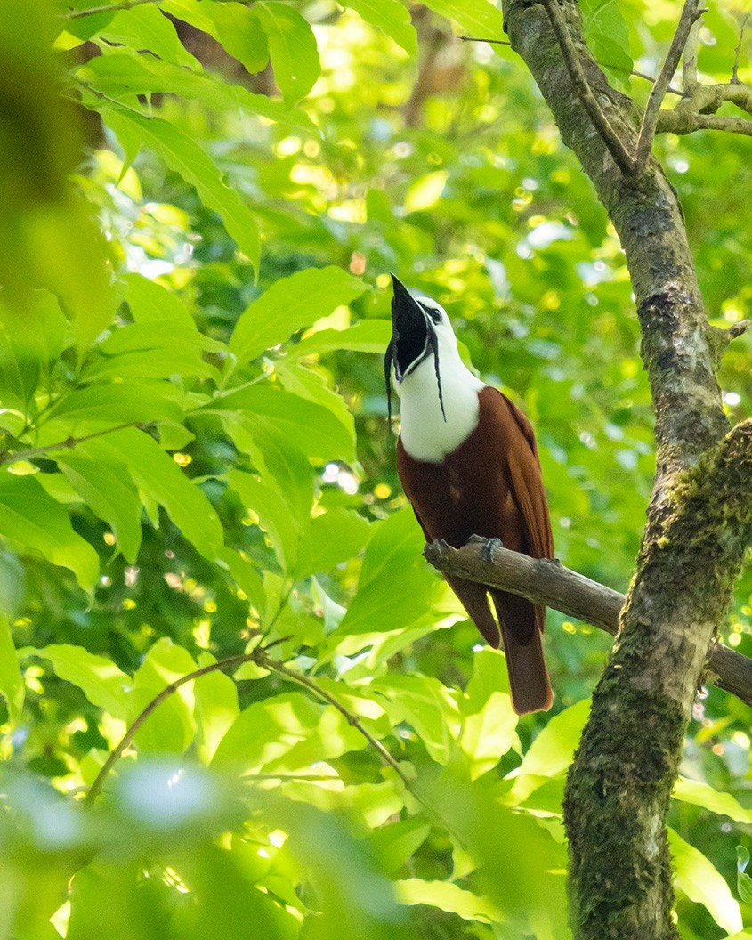Mar 2nd -Day 9: Birding by boat along the Río Frío.
An early morning as we meet our local guide and boat captain around 6am for a truly spectacular birding experience! Birding by boat along the Rio Frio, we will see a whole plethora of species, many of which are nearly impossible to see without slowly cruising the channels of this lowland river system. We will target a few key species, but will likely end up with a checklist over 100 species! Some main targets include: Jabiru, Green Ibis, Yellow-breasted Crake, American Pygmy Kingfisher, Green-and- Rufous Kingfisher, Black-collared Hawk, Nicaraguan Grackle, Pied Puffbird, Snowy Cotinga, Sungrebe, and if we are incredibly lucky, we may have a chance at the most sought-after heron in Central America, the Agami Heron!
The boat trip is a true highlight of any tour, and along with the birds, we will likely see a few Spectacled Caiman!
After lunch, we move southwest a couple hours to the Arenal area, where will will stay for the next 2 nights. This lush mid-elevation area has a dynamic mix of species, accented by the beautiful Arenal Volcano and Lake Arenal as backdrops most of the time.
Mar 3rd -Day 10: Arenal area & canopy towers
We will spend our day birding and enjoying all forms of nature as we check out a few great spots nearby. One of our destinations is Sky Adventures, an action/adventure tourism location that invites birders to enjoy their walking trails and canopy towers. From the towers, we can often spot Ornate Hawk-Eagles, as well as numerous canopy species as they move through in mixed flocks.
The other spot is bird-rich road that follows the edge of the lake down to the dam on Lake Arenal. This area is great for various Antbirds, Long-tailed Tyrants, Broad-billed Motmots, Thicket Antpittas, White-collared Manakins, and so so much more!
Mar 4th -Day 11: Final morning birding & Three-wattled Bellbirds
After another fantastic morning in the Arenal area, we will head to the higher elevations around San Ramon on our way back to the Central Valley. Taking small country roads along the foothills, we will arrive at a site where we will try our luck at spotting Three-wattled Bellbirds as they are staging before making their final ascent to the cloud-forest where they will set up territories and breed. These loud and neatly patterned birds are firmly on the Top 10 list of birds in Costa Rica, and with our search for them complete, we will return to the Central Valley for a celebratory dinner with a final bird list tally and storytelling! Tour officially concludes this night.
Mar 5ht - Day 12: International Departures
Shuttle services to the airport for international departures. For participants that choose to stay a day or two more, private arrangements can be made.

This itinerary is one we are very excited about, and will do everything we can to make sure it happens according to plan, but as with all tours, itinerary is subject to change depending on external circumstances including, but not limited to, things like weather.

Tour considerations

$4,095 per person - due 90 days before tour start date.
$500 deposit is required to secure your spot.
Based on double occupancy at lodgings, with a group size of 6 to 8 registrants. Maximum groups size is 8 registrants, plus guide(s) and driver(s).
If there are fewer than 6 registrants, this tour may be canceled or re-negotiated. Note that if you want a roommate we can try to find you one, but we cannot guarantee all guests a roommate.
If none is available, you will be charged the single supplement.

The cost covers:
- All lodging in twin/double or single occupancy
- Premier guide services from day 1 through day 11
- Private transportation in a spacious, comfortable vehicle with A/C
- All meals from dinner on day 1 through breakfast on day 12
- Shuttles in and out of San Jose International Airport
- Entrance Fees to nature reserves.
- 2 boat trips, Medio Queso and Cano Negro
- Costa Rica Bird Checklist
These things will not be included:
- International Airfare
- Tips for hotel staff, waiters, guides, and drivers during the trip.
- Items of personal use, toiletries
- Travel insurance
- Medical expenses, prescription drugs and other items of personal use
- Additional services offered in hotels (Spa, massage, etc.)
- Alcoholic beverages
- Laundry
- Souvenirs
- Any other expense or extra tours not listed as included

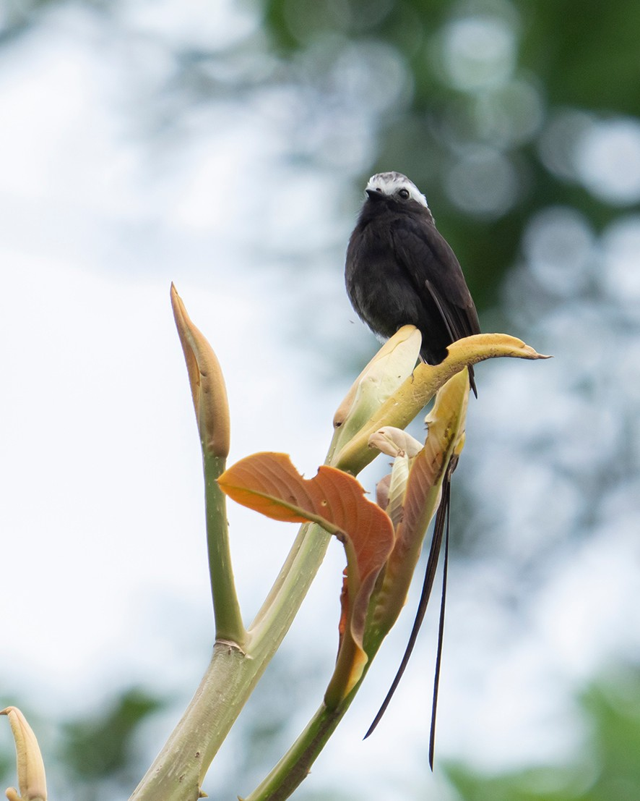
Long-tailed Tyrant

Documents
All travelers must have a current passport, valid for six months beyond the end date of this tour, with at least 1 blank page for stamps. No visa is required of US citizens entering Colombia. Proof of COVID-19 Vaccination is required to participate in and travel as a part of this tour.

Cancellation Policy
We strongly recommend all guests purchase travel insurance, including coverage for medical evacuation services and trip curtailment, in advance of this tour. It is important to protect against financial losses in the event that registrant becomes unable to participate in the tour. Note that such coverage is often non-refundable
so please check with the Joshua Covill of Glacier Birding Adventures before purchasing it, to confirm the tour is to proceed as planned.

If cancellation is received:
- 90 days or more prior to the start of the tour, a full refund is issued to registrant(s).
- 89 days or less prior to departure, a refund of tour payment and half of the deposit ($250) is issued to registrant(s).

Pace

Pace, pests, and climate

We have baked in a bit of flexibility on this tour, such that those desiring a hike or preferring to relax on certain afternoons have the option, and there's some stationary birding at lodges with great photo ops
Each morning we rise early, pre-dawn, to be in position to take advantage of the best time of day; when birds are most active near daybreak and soon thereafter. About half the days we lunch at our lodging, with time for a mid-day break before we return to birding activities. Often, hanging around the lodge grounds offer us the best chances for the birds we are seeking, or for photos of them. Dinners are at/near our accommodations.
The general plan is to be out birding the first ½ of the day and to enjoy some relaxing afternoons, taking advantage of our comfortable lodgings, most of which sport feeding stations, good photo opportunities, and trails with specialty birds and more. All birding is done along trails, roadsides, or around grounds of lodgings, and walking is at a slow pace so as not to startle wildlife and see as much as possible.
Elevation is a consideration on this tour. Please consult your physician regarding travel to areas of high elevation. Elevations range from 200 feet to about 11, 000 feet (700-3,400m) above sea level during our 11 day tour. Especially when up high, but really throughout the tour, we will take our time, and keep a slow and relaxed pace while we seek and enjoy birds and other wildlife.

Climate
Weather is variable throughout the tour, but generally we expect it to be pleasant and warm, though it can be quite cool when up high, and quite warm in the lowlands.
Temps in the lowlands will be between 75 and 85 F for daytime highs and 65 to 75 F for the lows. In the highlands, it can be 65 to 75 F for daytime highs and lows down to the low 40s F
February and March are in the dry season, so we expect clear sunny weather for most of our trip, although it is still the tropics! Afternoon rain showers are common, even in the dry season, although they don't last very long and we can often enjoy a beautiful post-rain evening!
Biting insects are usually not an issue when in middle and upper elevations, but may be a slight nuisance in the lowlands. That said, mosquitoes aren't ever as bad as the northern United States or Canada in summer. Still it may be wise to carry a small amount of insect repellant or to consider treating your clothing with repellant prior to departure.

Generally, nature enthusiasts visiting Costa Rica do not encounter diseases like Malaria, but it is possible, however extremely unlikely. We urge guests to consult a doctor about vaccinations and medications prior to travel.
Elevation sickness is possible given some of the areas we visit on this tour, so we urge guests to seek medical advice on spending time at high elevation as well. All participants are required to show proof of COVID-19 vaccinations.

The water is safe to drink everywhere in the country, but if you are ever unsure, we will make sure to get bottled/filtered water for you.

Packing

Please limit yourself to one mid-size suitcase/duffel and another smaller bag for daily use on outings. Group travel dictates we consider our fellow traveler’s comfort, and this includes not over-packing.
Laundry services are available at most hotels we visit but having lightweight clothes than can be hand- cleaned in rooms can be an advantage.
Lightweight clothing that is easy to layer is best for this variable climate that can be warm sometimes and downright cold at others.
Probably we will encounter some mist or rain, and perhaps wind as well. Lightweight raingear is recommended. Some folks bring umbrellas but if these are utilized they can obstruct viewing in certain situations.
Neutral colors are best for our time in the field to limit our visibility to the birds and wildlife we seek.
We could encounter some mud along trails and roadsides, so good trail shoes, hiking shoes or hiking boots are recommended for field outings, while a pair of slip-ons, flip flops, or comfortable walking shoes for around the hotels/lodges are good to have as well.
People can be surprised at traveling to a country along the equator only to find themselves up in the mountains where temperatures may drop to the low 40s F. We definitely recommend a thermal layer and a fleece/sweatshirt that can be layered under a raincoat to keep warm and dry. A pair of gloves and warm hat are recommended, and a buff (lightweight neckwarmer) for use as breathing barrier or for warmth can be helpful too.
Sunscreen, hat and sunglasses are good for when we encounter bright, clear conditions.
Light-weight clothing, preferably in long pants and long-sleeve shirts, is best for lowland birding as it keeps the bugs off but is light and breathable for the warm temps.
Shorts and T-shirts/tank tops are good for travel days and relaxing at the lodges.
A daypack (small backpack or the like) for your belongings for daily field outings is useful, and some folks find that having a walking stick for balance is nice to have.
Power outlets in Costa Rica are similar to those in the US/Canada, so no need for an adapter. Cell service is good in most areas but can be spotty in the highlands and along curvy mountain roads, and Wi-Fi is offered at all hotels but subject to disruption at times. A small supply of insect repellent is advisable.

